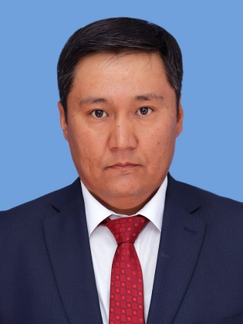

БАЙГЕБАЕВ Марат Оразбекович,
А.Макаренко атындагы №41 мектеп-лицейінің ағылшын тілі пәні мұғалімі.
Шымкент қаласы

Unit of a long term plan: Module:3  Мұғалімнің толық аты-жөні –Байгебаев Марат Оразбекович  ✅ Мектебі – 41 мектеп-лицей  ✅ ИИН - 831002302200  ✅ Пәні – ағылшын тілі  ✅ Облысы – Шымкент қаласы  ✅ Ауданы –  ✅ Ватсап телефоны – 87750051102 |  | School: №41 named after A.Makarenko
Date: 03.11.25 |  | Teacher’s name: Marat Baigebayev
Grade: 11 V |  | Number present: | absent:0
Lesson title | Parts of the human brain/Brain technology/Prepositional phrases
Learning objectives: | 11.4.2 - understand specific information and detail in extended texts on a wide range of familiar and unfamiliar general and curricular topics;  11.3.5 - interact with peers to make hypotheses and evaluate alternative proposals on a range of familiar and some unfamiliar general and curricular topics;
Lesson objectives | - All learners will be able to:  - Locate the information from the text quickly and identify meaning of the words.  - Check the meaning of the words by proofreading and editing
Level of thinking skills | Low /High order thinking skills
Stages / Time | Teacher actions | Students’ actions | Assessment | Resources
Beginning of the lesson  - min | Organization moment. Questionary  (Whole class) Teacher greets with students and asks following questions to revise previous materials unit 2 | Stustudents greet with the teacher and answer the following questions  They concentrate their attention to the question and revise previous materials | Teacher’s observation  Hands signal | Student’s book
10 min.  Middle of the lesson  10 min | Task I. Reading  Read the text and find the answer  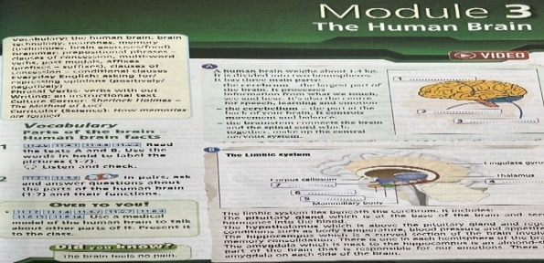  Task II Vocabulary and matching  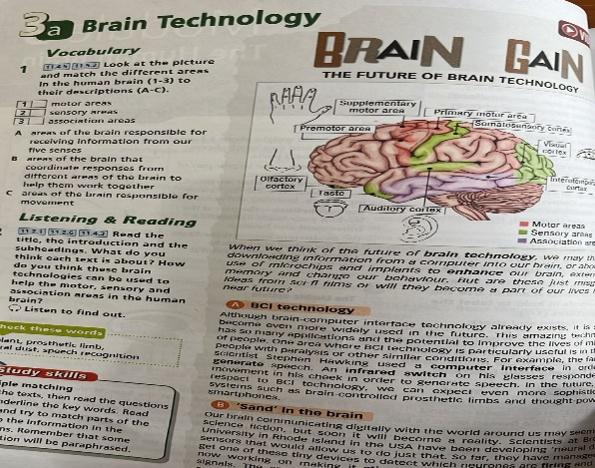 | Ss one by one talk about the picture and describe which is given on the whiteboard saying human brain  Gives extended answer.  Descriptor:  1. Ss apply topic related vocabulary and syntax  2. Ss identify the picture and explain with little support.  Ss match the subheading with appropriate paragraphs  Descriptor:  Ss identify the main point of each paragraph and then match the subtitles with appropriate paragraphs. | Teacher’s observation  Hands signal  Self assessment  teacher asks them to assess and check their answers by checking the context | Picture, pen or pencil, copybook,  Interactive board  Book
10 minutes | Task III Speaking  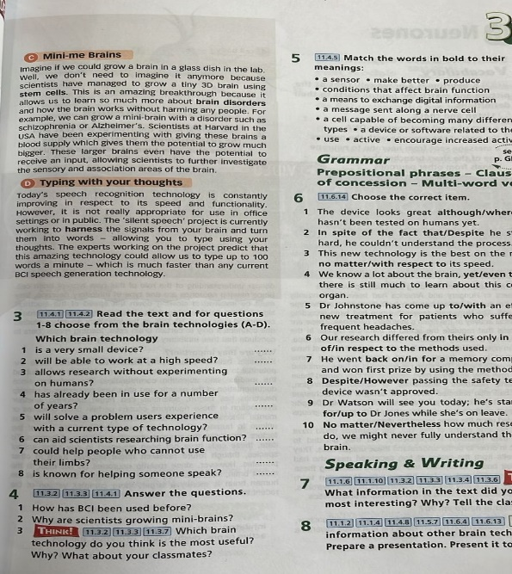 | Ss summarise the text or analise by their own ideas themselves and then answer following questions.  Less motivated students locate the information from the text and then answer 2-3 questions. Descriptor:  -Ss give full answer  -use the vocabulary | Teacher’s assessment | Handout 3
5min | Task IV  Differentiation:  Less motivated students make up 5-6 simple sentences about Brain technology  Teacher provides key words relating to topic. | Ss find information and generate ideas to make a plan for writing an essay. Descriptor:  Ss- make a plan writing about Brain technology  -write three sentences for each paragraph | Ss assess their idea with peers and help each other | Own idea and do some internet research
5 min Conclusion  End of the lesson | Speak about types of energy  Answer:  Ex.1 1. C motor areas  2.A sensory area  3. B association areas  Ex.3 1. B, 2 D, 3.C, 4A, 5D, 6 C, 7 B,  8 A  Ex. 4 1. BCI has been used before in order to help generate speech  2. Scientists are growing mini-brains in order to help them understand and learn more about the Human brain and brain disorders  Ex.5  - Brain technology=a device or software related to the brain  - Enhance= make better  - Computer interface= a means of exchange digital information  - Generate=produce  - Infrared switch=sensor  - Firing=active  - Stimulate= encourage increased activity  - Nerve impulse=a message sent along a nerve cell  - Stem cells= a cell capable of becoming many different cell types  - Brain disorders= conditions that affect brain function  - Harness= use | Students answer teacher’s questions | Teacher’s feedback CCQs
Homework | Ex.3,4,5 p.37 | Ss make speech | T: assess students’ written work and evaluate the gist of writing. | Internet, books

